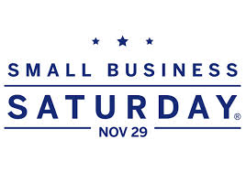
Here are the special promotions that the merchants of Bronx Little Italy
Are offering for Small Business Saturday on November 29th.
Check back daily as new promotions are listed!

Joe’s Italian Deli
10% off all purchases.
685 East 187th Street Bronx, NY 10458

Cosenza’s Fish Market
Free 1 ¼ pound lobster with a $100 dollar purchase. Must mention promo.
2354 Arthur Avenue Bronx, NY 10458

Mt. Carmel Pharmacy
Celebrating 50 Years Serving the Belmont Community
$19.99 Flu Shots originally $24.99. Must be 18 or older.
No prescription necessary, as the pharmacy is a New York Certified Immunizer.
If covered by your insurance, you would only be required to pay your co-pay.
Remember to bring your prescription drug plan card.
705 East 187th Street Bronx, NY 10458

Arthur Avenue Floral
50% off all non-Christmas items.
615 East 187th Street Bronx, NY 10458

Antonio’s Trattoria
10% off entire check.
2370 Belmont Avenue Bronx, NY 10458

