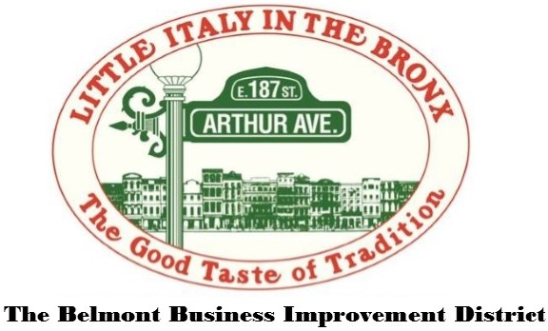
Bronx Little Italy Art Show

Expression of Interest Form
Sunday, June 28th, 2015
11AM – 4PM
Arthur Avenue & east 187th Street Bronx, New York
Name ____________________________________________________
Phone Number _______________ E-Mail _______________________
Type of art you will be showcasing ____________________________
________________________________________________________
Tables & chairs required (tables are 8ft x 30”) ___________________

I have read and agree to abide by all rules and regulations set forth by the Belmont Business Improvement District.
Signature __________________________ Date _____________

Please e-mail completed form to info@bronxlittleitaly.com

Rules & Regulations for the Bronx Little Italy Art Show
- These rules apply to all participants.
- A completed Expression of Interest Form does not guarantee a space, you must be confirmed by the Belmont BID prior to the event.
- There are no fees to participate in this event.
- All artists are welcome to participate in this event.
- No live or recorded music or any amplified sound without permission.
- If you are approved to participate in the event you will be assigned a designated space on the street that will be told to you prior to the event.
- Stands will be set up no more than 12 feet into the street perpendicular to the curb.
- No stands can be within 15 feet of a fire hydrant.
- You are responsible for unpacking, setting up, and packing up your artwork.
- You are responsible for parking your car. After initial set up, your car must be moved off of Arthur Avenue between East 187th Street & Crescent Avenue.

